STATIC ROUTING CONCEPTS
Q1. Open Cisco Packet Tracer and set up a simple network with two routers connected via a serial cable, assigning IP addresses to both router interfaces.
Ans. I have assigned bot the router IP’s with 30 CIDR
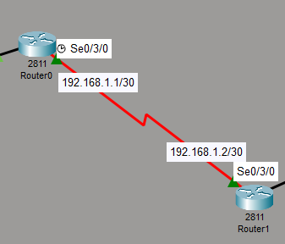
Q2. On Router1 in Cisco Packet Tracer, configure a static route so it can reach a PC connected to Router2’s LAN network. Test connectivity using the ping command from Router1 to the PC.
Ans. Here’s I have given static route between two routers and the pc of R1 is communicating with pc of R2.
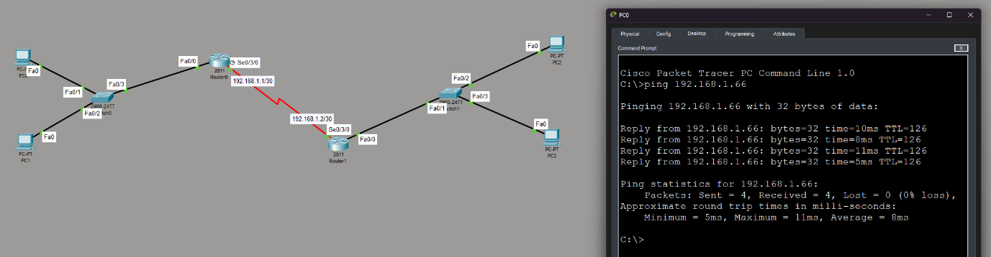
Q3. Simulate a Zomato-style delivery network: imagine Router1 represents an Ahmedabad branch and Router2 represents a Surat branch. Configure static routes so that devices in each city’s LAN can communicate with each other through the routers.
Ans. It is same as the above question as the R1 represents the Ahmedabad and R2 represents the Surat.
Q4. List two advantages and two disadvantages of static routing compared to dynamic routing, using examples from real-life apps like IRCTC or Swiggy to illustrate your points. Hint: Think about how static routes might impact delivery or booking updates in these apps.
Ans. Advantages and Disadvantages of Static Routing
- Advantages
No. | Advantage | Example
1 | Easy to Configure: Simple to set up and manage in small networks. | Swiggy can use static routing to connect two delivery offices.
2 | Low Resource Usage: Saves bandwidth because no regular routing updates are required. | IRCTC can use static routes for stable connections between internal systems.

- Disadvantages
No. | Disadvantage | Example
1 | No Automatic Route Changes: Cannot automatically switch to another path if a connection fails. | Swiggy's delivery tracking updates may be delayed if a network route fails.
2 | Difficult to Manage: Requires manual configuration when the network grows. | IRCTC may find it difficult to manage static routes across many booking systems.

